#### **Final Self-Assessment and Reflections – (SLO3)**

1. **First and Last name**: Ganesh Tadapaneni
2. **Date of analysis:** 12/18/2022
3. **Brief bio including:**

I go by the name Ganesh Tadapaneni in short. India's Andhra Pradesh state is where I was born. My only other sibling is my elder brother. I constantly strive to be practical and hardworking because to the cultural values I inherited from my family. Additionally, I always have the support and concern of my friends and coworkers.

Mechanical engineering was my major in college. I've always been attracted by engineering applications, which keeps me informed about cars.

I became more curious and eager to learn as I put in more hours at work, and this curiosity is what inspired me to further my career in IT infrastructure.

My master's degree in information technology and management helped me, in my opinion, to advance my knowledge, skills, and self-assurance as I seek to further my profession.

1. **Group Strengths Grid:**

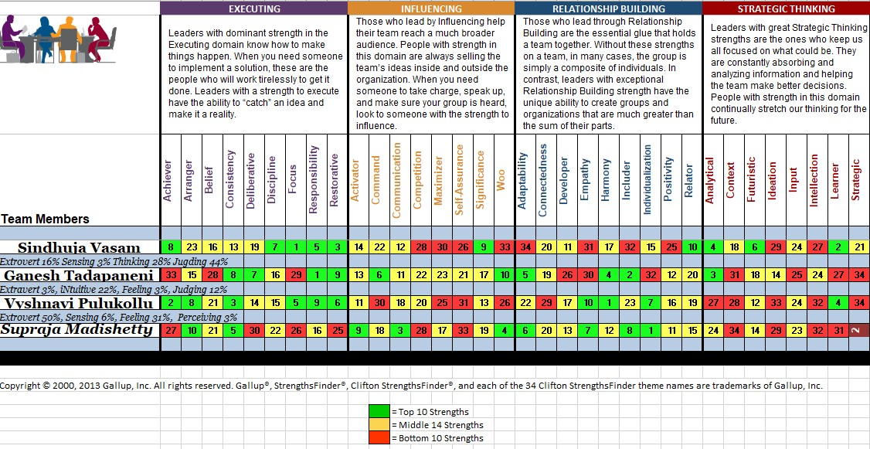

1. **Clifton Strengths Top 10 and Bottom 3 reflections**

**Responsibility**: I have no problem accepting responsibility for a certain conduct because I am a very responsible person. My ability to uphold the relationship with my team and make every effort to provide the best job is one of my fundamental strengths.

**Includer** - I tend to be more of a nerd and prefer working alone as opposed to with a group. This could be an issue for me, and I need to get better to fit in even if you want to be an entrepreneur. The ability to work well with others is the most crucial quality in a businessperson since it will help you draw in investors and keep your employees motivated to work hard for the firm. My goal is to get better at integrating myself into other people and working in a team.

**Analytical** - The ability to analyze data and acquire information in advance of a task is my best talent. I prefer to make decisions based on rationality. Even Nevertheless, if I have team members who are emotional thinkers, I should take their sentiments into account when making decisions because they can have an impact on teamwork.

**Harmony** - Because I am aware of my accomplishments and labor, I am successful today. Now, thanks to this skill, I have attained a harmony that embodies the purest, most straightforward kind of Wisdom. I can work with individuals without pressuring them to make any concessions since I don't have any attitude about my choices or the fundamental reasoning behind them.

**Adaptability** - Even though I am an extrovert according to my Myers-Briggs rating, I find it difficult to engage in conversation with new people and I find it difficult to adjust to a new environment until it gets acclimated to me. Additionally, I need to strengthen this weakness if I want to succeed in my life.

**Command** - By enabling me to store files, documents, and other material in one central area, Command aids in my organization. This makes sure that when I need it, I can quickly get the information. I can complete tasks more quickly and effectively because of this. To help me keep on track with my professional objectives, I use Command to assign myself deadlines and reminders.

**Deliberative** - When I have projects that call for production cutovers or moves, I want to be sure I know exactly what to do, and I prepare and test them on my own systems to make sure I can be 100% confident I know what to do when the deadline for that particular project approaches. This aids in presenting myself as a capable individual.

**Consistency** - It's all because I've been consistent that I've been able to advance my abilities faster than if I had just been trying with other methods sometimes. This increases my capacities and broadens my knowledge by enabling me to boldly explore new skills and continually build upon those I already have.

**Restorative** - My healing nature has made me popular with all of my coworkers and team members. It is something that will help things get better, allowing the people involved to view it as a highly practical solution to the issue. And because everyone knows I'll solve their problem and deal with it forcefully, I have a really good bond with my coworkers and fellow employees.

**Woo** - I've been the one to plant the seed for a favor or to extend it to those who ask. will assist by giving advice and a straightforward method for the team to receive the appropriate information. Additionally, it will be highly advantageous for the correct support.

1. **Bottom three clifton strengths**

**Strategic** **Thinking** - I've been able to create plans with a long-term vision in mind thanks to my strategic thinking abilities. I spend time thinking about many options and strategies so I can decide which will be most helpful for the success of my organization. This makes it possible to make judgments that are informed by goals and trends for the future.

**Achiever** - I consider myself to be an achiever, and I think that this quality distinguishes me from others and will be useful to me throughout my career. It has aided in my professional development, increased self-assurance at work, and ability to come up with original answers to challenging issues. I'm confident that success will always follow as long as I maintain my focus on pursuing perfection.

**Individualization** - Because it's crucial to recognize that each person has distinctive features that should be celebrated, individualization has helped me to grasp that my ability to communicate my awareness is my strength. In addition to helping me give the proper item, my expression and awareness will set me apart from everyone else.